# Get Windows Live™ SkyDrive™:art:WLMM_SBS_Cover.jpg

**Free tools for Collaboration**

**Step-by-Step for Educators**

Want to share a project online with students? With shared folders, the whole class can upload, download, and collaborate with you on documents and other files. Windows Live™ SkyDrive™ lets you easily store, access, and share your files—from anywhere. With 25 GB of free online storage, SkyDrive acts like your virtual hard drive on the internet where you can store all your files, photos, documents, etc., confidently.

**Download now**

1. Visit <http://WindowsLive.com/online/SkyDrive>.
2. Click **Get SkyDrive**.
3. If you have a Windows Live ID, log in and it will direct you to SkyDrive. If you do not already have a Windows Live ID, create one now.
4. Once you are logged in with your Windows Live ID, you can directly access your own SkyDrive by visiting <http://skydrive.live.com>.

Like other products in the Windows Live suite, SkyDrive is tightly integrated with the other Windows Live services. And because SkyDrive is the backend to Windows Live™ Photos, the photos that you upload to Windows Live automatically reside there too.

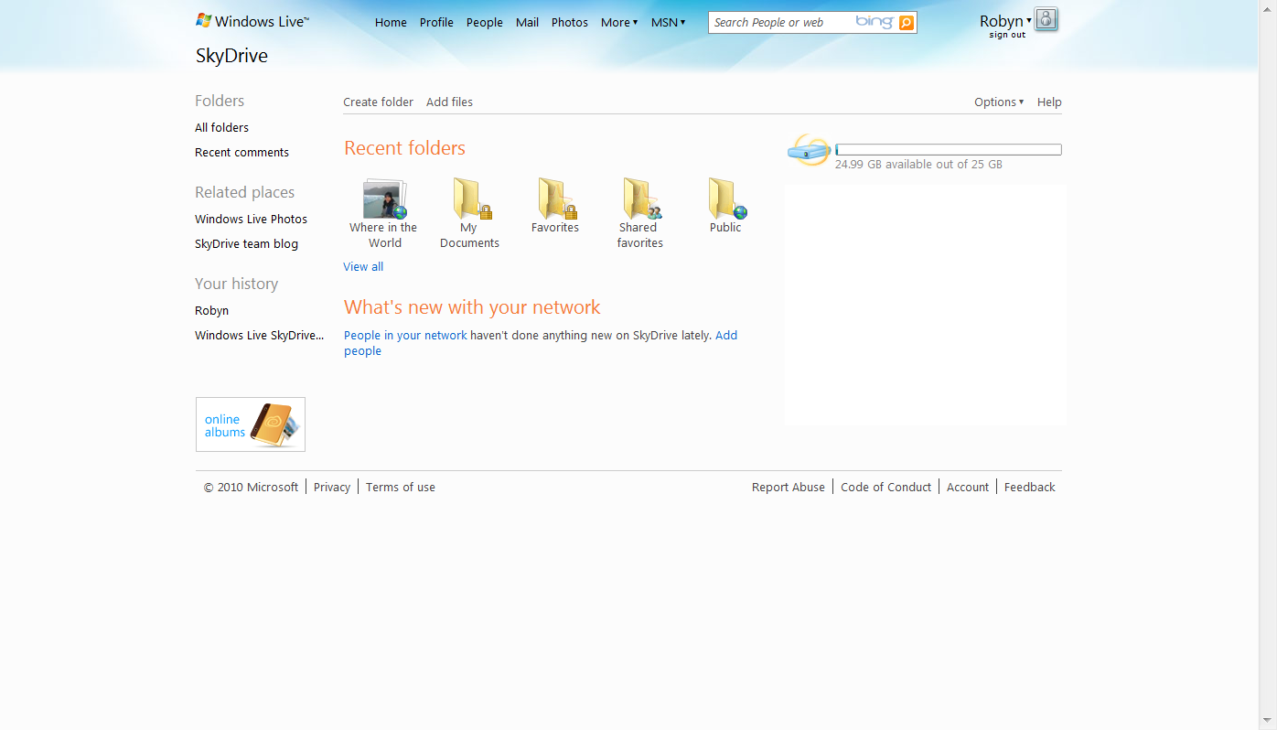

Photos uploaded to Windows Live Photos automatically reside in Windows Live SkyDrive.

## Upload Files

Uploading content is as easy as dragging and dropping the files from your computer onto the Web.

1. Click on **Create Folder**.
2. Fill in the **Name** field. Use the drop-down menu to indicate with whom you want to **share** the folder. Options are: Everyone (public), My network, Just me, and Select people.  
     
   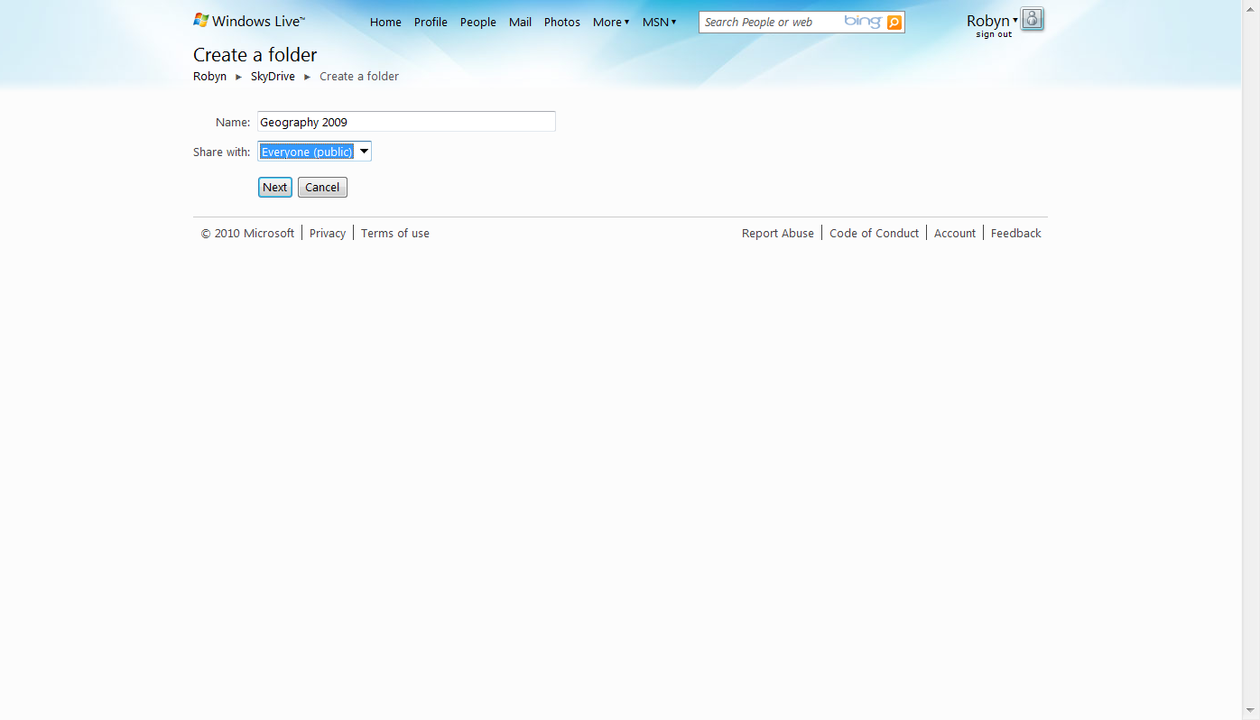
3. Click **Next**.
4. Now add files to the folder. Simply drag and drop files into the **Drop files here** area. Or, you may click on **Select files from your computer** to browse folders.  
     
   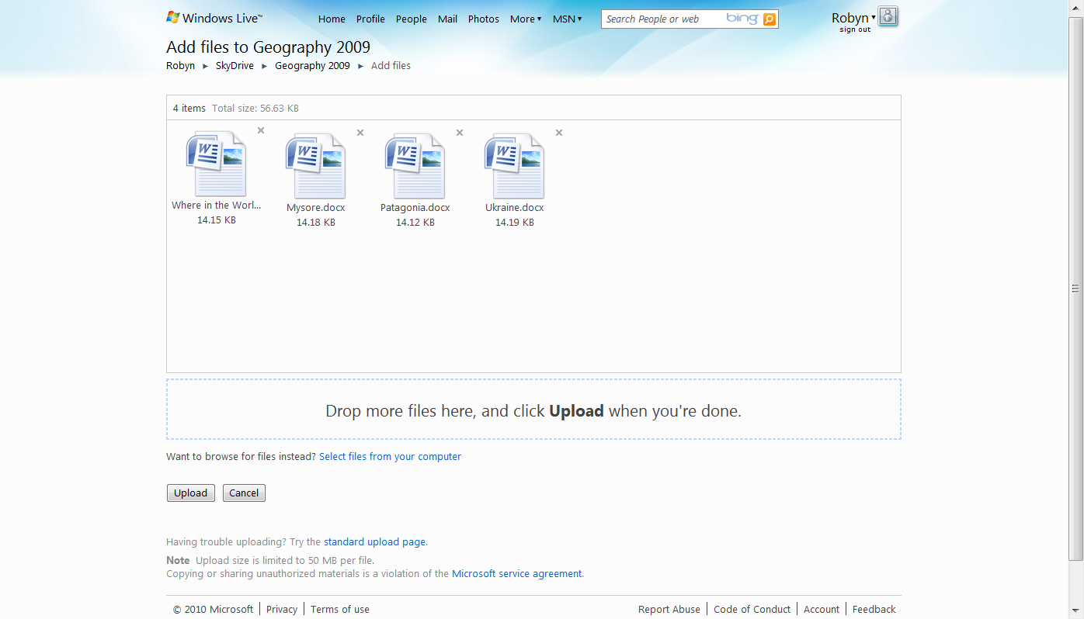
5. Click **Upload**.

## Share Files

1. Click **Send a link**.  
     
   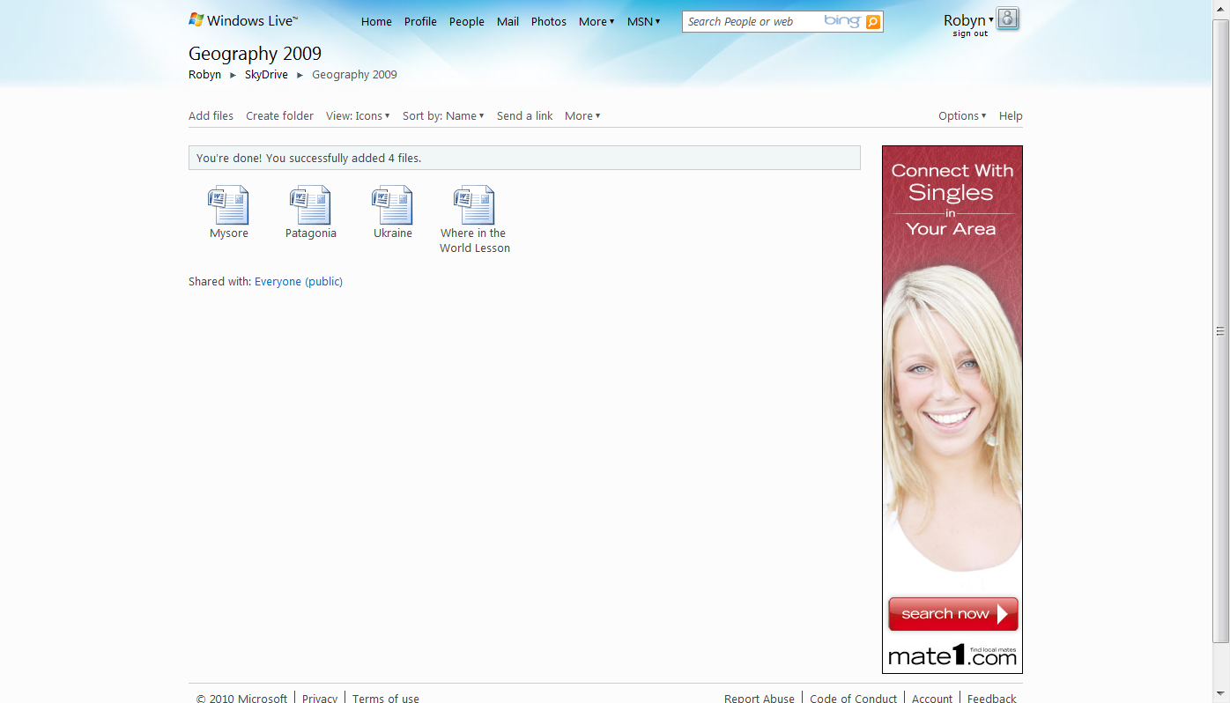
2. In the To field, enter the recipients’ email addresses. You can include a message about the files. Check **Don’t require recipients to sign in with Windows Live ID** so that all of your students can access the files. Then click **Send**.  
   *\*NOTE: You can save all of your students’ contact information in one category to make it easy to send links to SkyDrive to the term. See the next section.*  
   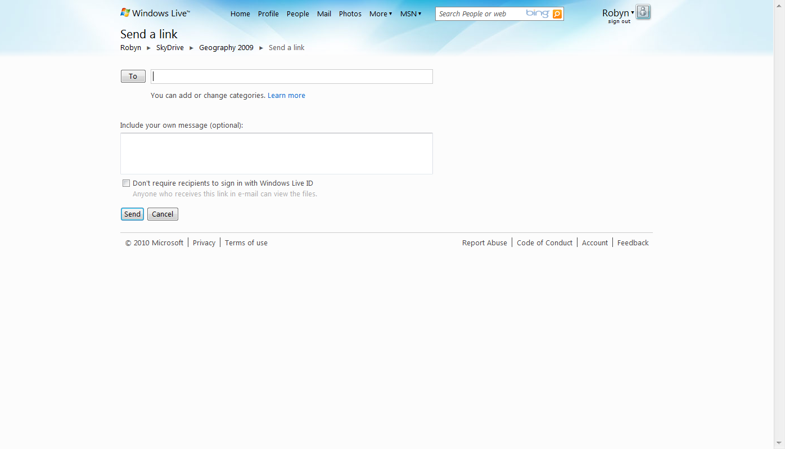
3. You will receive a send confirmation.  
     
   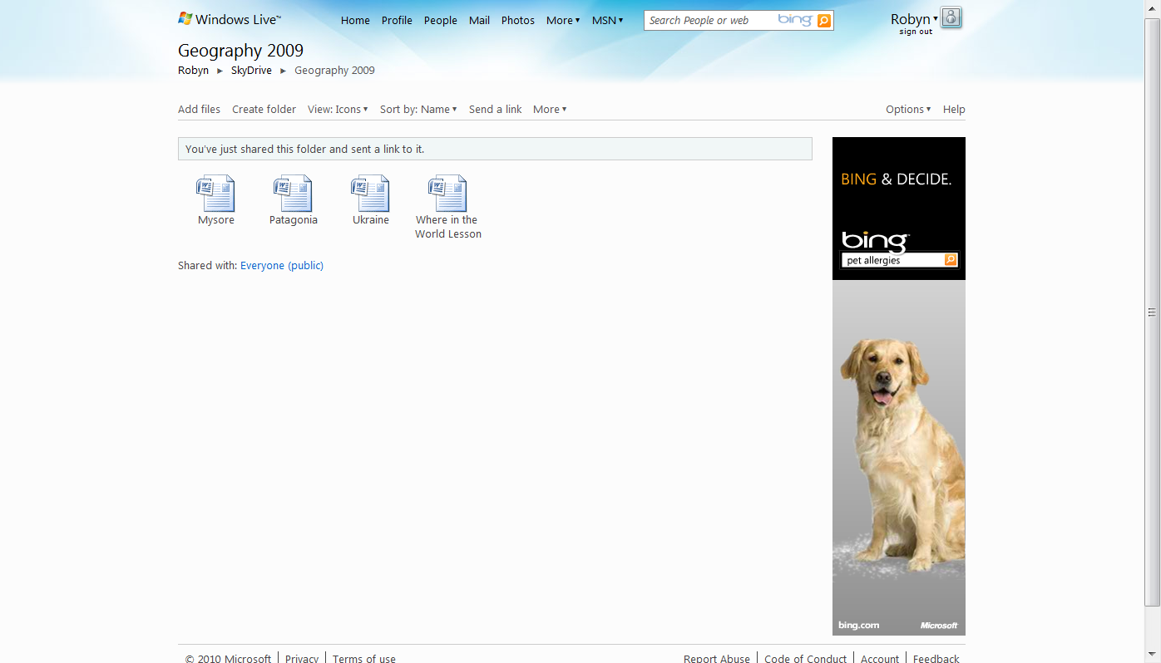

## Organize Contacts into Categories

You can organize your contacts in Windows Live into categories to make it easier to communicate with them by sending e-mails or SkyDrive invitations to all the people in a category at once.

### Create a New Category

1. Click **People** in the top navigation.
2. Click **Categories**.
3. Click **New category**.
4. Next to **Name**, type a name for the new category.
5. Next to **Members**, type the e-mail addresses that you want to add.
6. Click **Save**.

### Edit a Category

1. Click **People** in the top navigation.
2. In the left pane, click **Manage categories**.
3. Select a category, and then click **Edit**.
4. Do any of the following:
   * *Change Category Name:* Next to **Name**, type a name for the new category.
   * *Add People:* Under **Members**, type their e-mail address and then press **Enter**.
   * *Remove People:* Next to each person that you want to remove from the category, click the Remove contact icon remove contact.
5. Click **Save**.

### Delete a Category

1. Click **People** in the top navigation.
2. In the left pane, click **Manage categories**.
3. Select the category that you want to delete, and then click **Delete**.
4. In the dialog that opens, click **OK**.

# More Information on free tools for educators

**For teachers:**

[www.microsoft.com/education/freetools](http://www.microsoft.com/education/freetools)

**For faculty:**

[www.microsoft.com/freetools](http://www.microsoft.com/freetools)

For more information about Windows Live Services, including additional collaboration tools like Windows Live™ Groups, visit <http://windowslive.com/online/Groups> and

<http://help.live.com>

For more information about Microsoft resources for teachers, visit <http://www.microsoft.com/education>.

© 2009 Microsoft Corporation. All rights reserved.

This document is for informational purposes only. MICROSOFT MAKES NO WARRANTIES, EXPRESS, IMPLIED OR STATUTORY, AS TO THE INFORMATION IN THIS DOCUMENT.

Microsoft, Windows, Aero, BitLocker, BitLocker To Go, DirectX, Internet Explorer, OneNote, PowerPoint, SmartScreen, and Windows Live are trademarks of the Microsoft group of companies. The names of actual companies and products mentioned herein may be the trademarks of their respective owners.